**Digoxin**

**Pharmacology**

Positive (+) Inotrope (CHF)

Binds to Na+K+ATPase complex

Negative (-) Chronotrope (Atrial Fibrillation/Flutter or SVT)

Increases vagal tone to slow conduction through AV node

**Clinical uses**

* CHF
* Atrial Fibrillation/Flutter or SVT

**Pharmacokinetics**

**1. Absorption**

F= 0.7 (oral tablets), elixir (0.8)

* Aluminum containing antacids, high fiber & cholestyramine decrease digoxin absorption (separate by 2 hrs)
* Some antibiotics may increase bioavailability

**2. Distribution**

* 2 compartment model
  + Vi = Initial
  + Vd = Larger, more slowly equilibrating (Myocardium)

**Central volume of distribution (Vi)**

**Vd (tissues)**

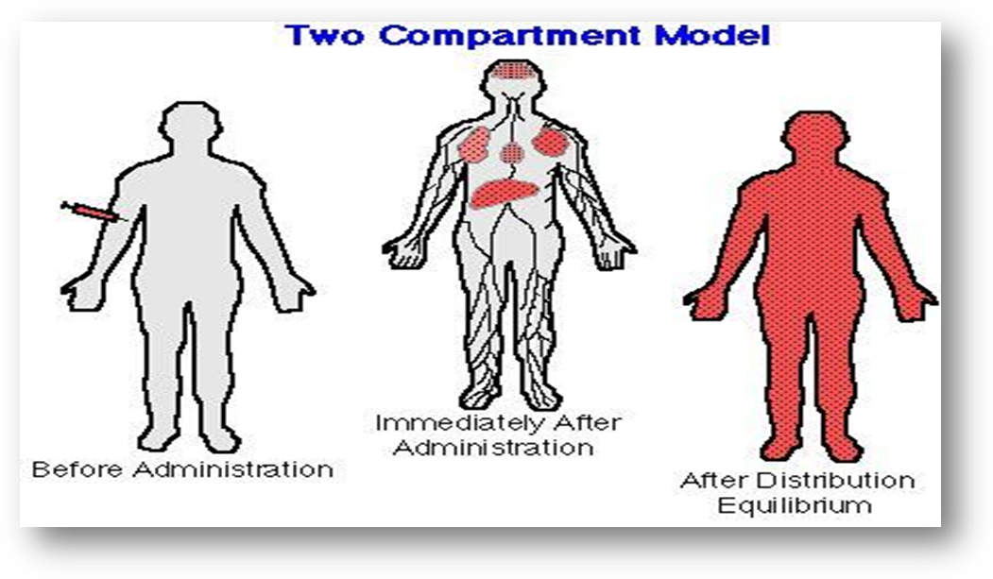

**SLOW**

* Vd – 7 L/kg (based on IBW in obesity)
  + 4-5 L/kg in renal failure (CrCl < 30 ml/min) **OR**
  + Vd in renal failure (CrCl < 30 ml/min: http://www.accesspharmacy.com/loadBinary.aspx?name=baue2&filename=baue2_c006eq001.gif
* Long distribution phase 8-12 hours
* Protein binding: 25%

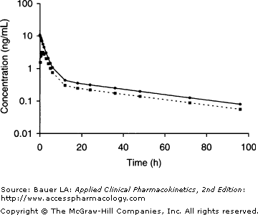

End of distributive phase

(8-12 hrs after dose)

**Question:**

A 68 y/o male with atrial fibrillation uncontrolled on metoprolol 100 mg PO q12 and diltiazem CD 360 mg daily. The team gives a digoxin loading dose: 0.5 mg at 12 noon, 0.25 mg at 6 pm and 0.25 mg at midnight. A digoxin serum concentration was drawn at 4 am and found to be 3.6 mcg/L. Based on what you know about digoxin’s distribution phase, what is the best explanation as to why this patient’s digoxin concentration is supratherapeutic?

**3. Transport**

* via P-glycoprotein efflux pumps in intestines (enterocytes), bile, kidneys



**Adapted from J. Horn, P. Hansten. Pharmacy Times 2004**

[**http://www.hanstenandhorn.com/hh-article10-04.pdf**](http://www.hanstenandhorn.com/hh-article10-04.pdf) **accessed: January 2010**

**4. Clearance**

* t1/2 = 24-48 hours (normal renal function)
* < 20% via hepatic metabolism
* Hydrolysis pathway via stomach acidandreduction pathway by intestinal bacteria
* Primarily eliminated unchanged by the kidney (75%)by glomerular filtration and tubular secretion via **p-glycoprotein**
* Cl = Cl renal + Cl nonrenal
  + Digoxin clearance (ml/min) w/o CHF = 1.3(CrCl) + 40ml/min
  + Digoxin clearance w/ CHF Class III or IV= 1.3 (CrCl) + 20 ml/min

|  |  |
| --- | --- |
| **Factors that alter digoxin clearance** | |
| **Decrease** | **Increase** |
| Hypothyroidism | Hyperthyroidism |
| Renal dysfunction |  |
| CHF (related to renal function) |  |
| Neonates |  |
| Drug interactions |  |

**Dosing  
Oral formulations:**

0.125 mg tablet (125 mcg) and 0.25 mg tablet (250 mcg), 50 mcg/ml oral solution

**Injection:**

250 mcg/ml, 100 mcg/ml

**Standard Dosing:**

**Loading dose:** Generally give ½ dose initially, ¼ dose 4-6 hrs later, ¼ dose 6 hrs later

**Maintenance dose:** 0.125 -0.25 mg but varies based on indication and renal function

**Monitoring**

* Therapeutic range: 0.8 to 2 mcg/L
* CHF: 0.5 to 0.8 mcg/L
* Atrial fibrillation: 1-2 mcg/L
* When to measure serum concentrations:
* After loading dose:
* **Must wait until distribution phase is over**
* Trough:

1. Ideally 7-14 days after initiation or change in therapy (at steady-state)

2. If clinical deterioration occurs following a good response

4. Change in renal function

5. When digoxin toxicity is suspected

6. Upon initiation or d/c of interacting medication or condition (i.e. hypothyroidism)

**Adverse drug reactions**

* CNS: fatigue, visual, complaints, headache, confusion/psychoses, seizures
* GI: anorexia, abdominal upset, N/V/D
* Cardiac: premature ventricular contractions, heart block, cardiac arrhythmias

**Drug interactions (many!):**

* Amiodarone
* Cyclosporine
* Dronedarone
* Macrolide antibiotics
* Propafenone
* Quinidine
* Itraconazole
* Verapamil, diltiazem
* Diuretic induced electrolyte abnormalities (hypokalemia and hypomagnesemia)

**Digoxin toxicity**

**1. DigiFab ® (Digoxin immune antigen binding fragments)**

* Indicated for life-threatening digoxin intoxication
* Any arrhythmia refractory to usual treatment
* Hyperkalemia
* Ingestion of >10 mg in adults or 0.1 mg/kg in children
* Serum concentration > 6-10 mcg/L
* Mechanism: digoxin antibody fragment (Fab) that binds to plasma digoxin and is eliminated in the urine
* Dosing:
* 1 vial (40 mg) binds 0.5 mg of digoxin

OR

* DigiFab (no. of vials) = Digoxin concentration (mcg/L) x weight in kg

100

* Other important facts:
* Dosing equation assumes Vd 5 L/kg
* Some digoxin assays measure bound and unbound digoxin which can include DigiFab
* Patients with renal failure cannot eliminate DigiFab
* Allergic reactions may occur with administration of DigiFab

**Formulas**

Loading dose = (Cdes) ( Vd)

F S

Vd= 7 L/kg

In renal failure:

Vd= 226 + 298 *CrCl * (Wt/70)

29.1 + CrCl

Digoxin clearance (ml/min) w/o CHF = 1.3(CrCl) + 40ml/min

Digoxin clearance w/ CHF= 1.3 (CrCl) + 20 ml/min

Cl= (ke)( Vd)

T 1/2= (0.693)(Vd)

Cl

Maintenance Dose= (Cl ) (Css)(τ)

F S

**Question 1:**

KM is a 56 yo male with PMH significant for NYHA Class III CHF, atrial fibrillation and CKD. KM presents to the ER with a feeling of palpitations and dizziness.

Current meds:

Warfarin 5 mg daily

Enalapril 5 mg daily

Metoprolol 100 mg BID

Furosemide 40 mg daily

VS: BP 96/52 HR 140 irreg irreg RR 20 Temp 99◦F Wt 80 kg Ht 5’6” inches

Pertinent labs: SCr 3.5 K+ 5

**The resident has decided to load KM on oral digoxin tablets to obtain ventricular rate control. The resident would like to obtain a serum digoxin concentration of 1 mcg/L. Calculate a loading dose for KM.**

1. **Determine if patient is obese and CrCl**
2. **Calculate volume of distribution**
3. **Calculate loading dose**

**Question 2: Calculate a Maintenance dose for KM with a goal steady-state serum level of 1 mcg/L.**

1. **Calculate CrCl using the Cockcroft-Gault Method and determine if patient has CHF. Calculate clearance.**
2. **Calculate the maintenance dose, using the following formula:**
3. **Calculate Css based on the maintenance dose you calculated.**

1. **If you want to check a serum level at steady state to be sure you achieved a therapeutic level, when can you do so?**

**Question 3: Two weeks later KM is admitted back into the hospital with bradycardia. He was taking digoxin tablets 125 mcg daily at home. His steady state concentration is 2.5mcg/L. Calculate a new dose for KM. Target digoxin concentration 1.2 mcg/L.**

**1. Calculate clearance based on actual concentrations.**

**2. Compute new dose based on actual clearance**

Gvngvhd

**Question 4:** A mother brings her 2 month old child (5.5 kg) into the emergency room after noticing that she had been administering 2.5 ml of the 50mcg/ml digoxin solution to her baby instead of 0.25 ml. The digoxin concentration was 13 mcg/L. Should we administer DigiFab to this patient? If so, what dose would we administer? **Note: Dosing in pediatrics is based in mg (40 mg/vial)**